Assessment-3 (Part 2)
AIM
Experiment-10(a) Construct Simple LR (SLR) parse table using C language.
Experiment-10(b) Implement the LR parsing algorithm, get both parse table and input string are inputs. Use C language for implementation.

ALGORITHM
- Input grammar productions and identify the start symbol.
- Augment the grammar by adding a new start production @ → S.
- Identify all non-terminals and terminals from the productions.
- Construct the initial LR(0) item set I₀ using closure of @ → .S.
- Generate canonical LR(0) item sets using GOTO(I, X) for every symbol.
- Repeat GOTO generation until no new states are produced.
- Compute FIRST sets for all non-terminals.
- Compute FOLLOW sets for all non-terminals.
- Construct the SLR parsing table using LR(0) states and FOLLOW sets.
- Fill SHIFT actions for transitions on terminals from the GOTO table.
- Fill REDUCE actions when an item has the dot at the end of a production.
- Mark ACCEPT action for the item @ → S. with input $.
- Initialize parsing stack with state 0 and append $ to the input string.
- Read the current state and input symbol to consult the ACTION table.
- Perform SHIFT by pushing the next state and moving the input pointer.
- Perform REDUCE by popping states equal to RHS length and pushing GOTO state of LHS.
- Repeat SHIFT/REDUCE steps until ACCEPT or ERROR occurs.
- If ACCEPT occurs → string is valid, otherwise reject the string.

SOURCE CODE
/*
* SLR (Simple LR) Parser
* -----------------------
* UPPERCASE letters = Non-Terminals (E, T, F, S, A, B ...)
* lowercase letters = Terminals (a, b, c, d, i, x ...)
*
* Input format: E=EaT means E -> EaT
* Augmented start: program adds @ -> original_start internally
* '@' is used as the augmented symbol (not typeable by user)
*
* Prints: Closure of I0,I1,... | GOTO transitions | FOLLOW sets
* SLR Parse Table | Step-by-step parse trace
*
* All variables declared at top of each function (C89 compatible)
*/

#include <stdio.h>
#include <stdlib.h>
#include <string.h>

#define MAXP 30
#define MAXS 80
#define MAXR 20
#define MAXSYM 50
#define MAXITEM 300
#define ACCEPT -2
#define ERR -3

/* ── Grammar ── */
int numProd;
char lhs[MAXP];
char rhs[MAXP][MAXR];
int rhsLen[MAXP];

/* ── Symbol tables ── */
char nonTerminals[MAXSYM]; int numNT = 0;
char terminals[MAXSYM]; int numT = 0;
char allSymbols[MAXSYM]; int numAll = 0;

/* ── LR(0) Items ── */
typedef struct { int prod; int dot; } Item;
typedef struct { Item items[MAXITEM]; int count; } State;

State states[MAXS];
int numStates = 0;
int gotoTbl[MAXS][MAXSYM]; /* internal: gotoTbl[state][symIdx] = next state */

/* ── Parse tables ── */
int actTable[MAXS][MAXSYM]; /* [state][tIdx], >=0 shift, -(p+10) reduce */
int gotoTable[MAXS][MAXSYM]; /* [state][ntIdx], >=0 goto state */

/* ── FIRST / FOLLOW bitmasks ── */
int firstSet[MAXSYM]; /* indexed by ntIdx */
int followSet[MAXSYM]; /* indexed by ntIdx, bit numT = '$' */

/* ══════════════════════════════════════════
HELPERS
uppercase = NT, lowercase = terminal
══════════════════════════════════════════ */

int isNT(char c) {
return (c >= 'A' && c <= 'Z');
}

int ntIdx(char c) {
int i;
for(i = 0; i < numNT; i++) if(nonTerminals[i] == c) return i;
return -1;
}

int tIdx(char c) {
int i;
for(i = 0; i < numT; i++) if(terminals[i] == c) return i;
return -1;
}

void addNT(char c) {
int i;
for(i = 0; i < numNT; i++) if(nonTerminals[i] == c) return;
nonTerminals[numNT++] = c;
}

void addT(char c) {
int i;
for(i = 0; i < numT; i++) if(terminals[i] == c) return;
terminals[numT++] = c;
}

void addSym(char c) {
int i;
for(i = 0; i < numAll; i++) if(allSymbols[i] == c) return;
allSymbols[numAll++] = c;
}

/* ══════════════════════════════════════════
CLOSURE (LR(0))
For [A->a.Bb]: add [B->.g] for every B->g
══════════════════════════════════════════ */
void computeClosure(State *st) {
int changed, i, q, k, found, p, d;
char B;

changed = 1;
while(changed) {
changed = 0;
for(i = 0; i < st->count; i++) {
p = st->items[i].prod;
d = st->items[i].dot;
if(d >= rhsLen[p]) continue;
B = rhs[p][d];
if(!isNT(B)) continue;
for(q = 0; q < numProd; q++) {
if(lhs[q] != B) continue;
found = 0;
for(k = 0; k < st->count; k++)
if(st->items[k].prod == q && st->items[k].dot == 0) { found = 1; break; }
if(!found) {
st->items[st->count].prod = q;
st->items[st->count].dot = 0;
st->count++;
changed = 1;
}
}
}
}
}

/* ══════════════════════════════════════════
GOTO(I, X) = closure of items with dot moved over X
══════════════════════════════════════════ */
int computeGoto(int si, char X, State *out) {
int i, k, found;
Item ni;
State *st;

st = &states[si];
out->count = 0;
for(i = 0; i < st->count; i++) {
if(st->items[i].dot < rhsLen[st->items[i].prod] &&
rhs[st->items[i].prod][st->items[i].dot] == X) {
ni.prod = st->items[i].prod;
ni.dot = st->items[i].dot + 1;
found = 0;
for(k = 0; k < out->count; k++)
if(out->items[k].prod == ni.prod && out->items[k].dot == ni.dot) { found = 1; break; }
if(!found) out->items[out->count++] = ni;
}
}
if(out->count == 0) return -1;
computeClosure(out);
return 0;
}

int statesEqual(State *a, State *b) {
int i, j, found;
if(a->count != b->count) return 0;
for(i = 0; i < a->count; i++) {
found = 0;
for(j = 0; j < b->count; j++)
if(a->items[i].prod == b->items[j].prod &&
a->items[i].dot == b->items[j].dot) { found = 1; break; }
if(!found) return 0;
}
return 1;
}

/* ══════════════════════════════════════════
BUILD CANONICAL LR(0) COLLECTION
══════════════════════════════════════════ */
void buildStates() {
int i, j, s, found;
State tmp;

states[0].count = 0;
states[0].items[0].prod = 0; /* @ -> .S */
states[0].items[0].dot = 0;
states[0].count = 1;
computeClosure(&states[0]);
numStates = 1;

for(i = 0; i < MAXS; i++)
for(j = 0; j < MAXSYM; j++)
gotoTbl[i][j] = -1;

for(i = 0; i < numStates; i++) {
for(s = 0; s < numAll; s++) {
tmp.count = 0;
if(computeGoto(i, allSymbols[s], &tmp) < 0) continue;
found = -1;
for(j = 0; j < numStates; j++)
if(statesEqual(&states[j], &tmp)) { found = j; break; }
if(found < 0) { states[numStates] = tmp; found = numStates++; }
gotoTbl[i][s] = found;
}
}
}

/* ══════════════════════════════════════════
PRINT CLOSURES I0, I1, ...
══════════════════════════════════════════ */
void printStates() {
int i, j, k, s;
Item it;

printf("\n========== LR(0) ITEMS (Closures) ==========\n");
for(i = 0; i < numStates; i++) {
printf("\nI%d:\n", i);
for(j = 0; j < states[i].count; j++) {
it = states[i].items[j];
printf(" %c -> ", lhs[it.prod]);
for(k = 0; k < rhsLen[it.prod]; k++) {
if(k == it.dot) printf(".");
printf("%c", rhs[it.prod][k]);
}
if(it.dot == rhsLen[it.prod]) printf(".");
printf("\n");
}
}

/* ── Individual GOTO transitions ── */
printf("\n========== GOTO TABLE ==========\n");
printf("%-8s", "State");
for(s = 0; s < numAll; s++) printf(" %-5c", allSymbols[s]);
printf("\n");
for(i = 0; i < numStates; i++) {
printf("%-8d", i);
for(s = 0; s < numAll; s++) {
if(gotoTbl[i][s] >= 0) printf(" I%-4d", gotoTbl[i][s]);
else printf(" %-5s", "--");
}
printf("\n");
}
}

/* ══════════════════════════════════════════
FIRST SETS
══════════════════════════════════════════ */
void computeFirst() {
int changed, p, k, ni, old, xi, allEps;
char X;

memset(firstSet, 0, sizeof(firstSet));
changed = 1;
while(changed) {
changed = 0;
for(p = 0; p < numProd; p++) {
ni = ntIdx(lhs[p]);
old = firstSet[ni];
if(rhsLen[p] == 0) {
firstSet[ni] |= (1 << numT);
} else {
allEps = 1;
for(k = 0; k < rhsLen[p]; k++) {
X = rhs[p][k];
if(!isNT(X)) { firstSet[ni] |= (1 << tIdx(X)); allEps = 0; break; }
else {
xi = ntIdx(X);
firstSet[ni] |= (firstSet[xi] & ~(1 << numT));
if(!(firstSet[xi] & (1 << numT))) { allEps = 0; break; }
}
}
if(allEps) firstSet[ni] |= (1 << numT);
}
if(firstSet[ni] != old) changed = 1;
}
}
}

/* ══════════════════════════════════════════
FOLLOW SETS
══════════════════════════════════════════ */
void computeFollow() {
int changed, p, i, j, bi, yi, old, fb, allEps;
char B, Y, orig;

memset(followSet, 0, sizeof(followSet));
orig = rhs[0][0]; /* original start symbol */
followSet[ntIdx(orig)] |= (1 << numT); /* $ in FOLLOW(start) */

changed = 1;
while(changed) {
changed = 0;
for(p = 0; p < numProd; p++) {
for(i = 0; i < rhsLen[p]; i++) {
B = rhs[p][i];
if(!isNT(B)) continue;
bi = ntIdx(B);
old = followSet[bi];
fb = 0;
allEps = 1;
for(j = i + 1; j < rhsLen[p]; j++) {
Y = rhs[p][j];
if(!isNT(Y)) { fb |= (1 << tIdx(Y)); allEps = 0; break; }
else {
yi = ntIdx(Y);
fb |= (firstSet[yi] & ~(1 << numT));
if(!(firstSet[yi] & (1 << numT))) { allEps = 0; break; }
}
}
followSet[bi] |= fb;
if(allEps) followSet[bi] |= followSet[ntIdx(lhs[p])];
if(followSet[bi] != old) changed = 1;
}
}
}
}

void printFollowSets() {
int i, j;
printf("\n========== FOLLOW Sets ==========\n");
/* print for all NTs except augmented '@' */
for(i = 0; i < numNT; i++) {
if(nonTerminals[i] == '@') continue;
printf("FOLLOW(%c) = { ", nonTerminals[i]);
for(j = 0; j < numT; j++)
if(followSet[i] & (1 << j)) printf("%c ", terminals[j]);
if(followSet[i] & (1 << numT)) printf("$ ");
printf("}\n");
}
}

/* ══════════════════════════════════════════
BUILD SLR PARSE TABLE
══════════════════════════════════════════ */
void buildParseTable() {
int i, j, s, t, p, ni, val;
Item it;
char X;

for(i = 0; i < MAXS; i++)
for(j = 0; j < MAXSYM; j++) { actTable[i][j] = ERR; gotoTable[i][j] = -1; }

for(i = 0; i < numStates; i++) {
/* shifts and GOTO from internal gotoTbl */
for(s = 0; s < numAll; s++) {
if(gotoTbl[i][s] < 0) continue;
X = allSymbols[s];
if(isNT(X)) gotoTable[i][ntIdx(X)] = gotoTbl[i][s];
else actTable[i][tIdx(X)] = gotoTbl[i][s]; /* shift */
}
/* reduces */
for(j = 0; j < states[i].count; j++) {
it = states[i].items[j];
if(it.dot < rhsLen[it.prod]) continue;
p = it.prod;
if(p == 0) { actTable[i][numT] = ACCEPT; continue; } /* @ -> S. */
ni = ntIdx(lhs[p]);
for(t = 0; t <= numT; t++) {
if(!(followSet[ni] & (1 << t))) continue;
val = -(p + 10);
if(actTable[i][t] != ERR && actTable[i][t] != val)
printf("WARNING: SLR conflict state %d symbol %c\n",
i, t < numT ? terminals[t] : '$');
actTable[i][t] = val;
}
}
}
}

/* ══════════════════════════════════════════
PRINT SLR PARSE TABLE
ACTION columns: all terminals + $
GOTO columns: all non-terminals EXCEPT '@' (augmented)
══════════════════════════════════════════ */
void printParseTable() {
int i, t, n, v;
char c;

printf("\n========== SLR PARSE TABLE ==========\n");
printf("%-6s| ACTION", "State");
for(t = 0; t <= numT; t++) {
c = (t < numT) ? terminals[t] : '$';
printf(" %-5c", c);
}
printf(" | GOTO");
for(n = 0; n < numNT; n++) {
if(nonTerminals[n] == '@') continue; /* skip augmented symbol */
printf(" %-4c", nonTerminals[n]);
}
printf("\n");

for(i = 0; i < numStates; i++) {
printf("%-6d| ", i);
for(t = 0; t <= numT; t++) {
v = actTable[i][t];
if(v == ERR) printf(" %-5s", "err");
else if(v == ACCEPT) printf(" %-5s", "acc");
else if(v >= 0) printf(" S%-4d", v);
else printf(" R%-4d", -(v + 10));
}
printf(" | ");
for(n = 0; n < numNT; n++) {
if(nonTerminals[n] == '@') continue;
if(gotoTable[i][n] >= 0) printf(" %-4d", gotoTable[i][n]);
else printf(" %-4s", "--");
}
printf("\n");
}
}

/* ══════════════════════════════════════════
LR PARSER
══════════════════════════════════════════ */
void parse(char *input) {
int len, ip, top, s, ai, v, p, t2, ni, g, i, pos;
char a;
int stk[500];
char stkStr[300], inStr[200];

len = (int)strlen(input);
printf("\n========== PARSING: %s$ ==========\n", input);
printf("%-30s %-22s %-25s\n", "STACK", "INPUT", "ACTION");
printf("%-30s %-22s %-25s\n", "-----", "-----", "------");

stk[0] = 0; top = 0; ip = 0;

while(1) {
s = stk[top];
a = (ip < len) ? input[ip] : '$';
ai = (a == '$') ? numT : tIdx(a);

pos = 0;
for(i = 0; i <= top; i++) pos += sprintf(stkStr + pos, "%d ", stk[i]);
for(i = ip; i < len; i++) inStr[i - ip] = input[i];
inStr[len - ip] = '\0'; strcat(inStr, "$");

if(ai < 0) {
printf("%-30s %-22s Error: unknown symbol '%c'\n", stkStr, inStr, a);
return;
}

v = actTable[s][ai];

if(v == ACCEPT) {
printf("%-30s %-22s ACCEPT\n", stkStr, inStr);
printf("\nString \"%s\" is ACCEPTED by the grammar.\n", input);
return;
} else if(v == ERR) {
printf("%-30s %-22s ERROR\n", stkStr, inStr);
printf("\nString \"%s\" is REJECTED by the grammar.\n", input);
return;
} else if(v >= 0) {
printf("%-30s %-22s Shift to state %d\n", stkStr, inStr, v);
stk[++top] = v; ip++;
} else {
p = -(v + 10);
printf("%-30s %-22s Reduce: %c -> ", stkStr, inStr, lhs[p]);
for(i = 0; i < rhsLen[p]; i++) printf("%c", rhs[p][i]);
printf(" (prod %d)\n", p);
top -= rhsLen[p];
t2 = stk[top];
ni = ntIdx(lhs[p]);
g = gotoTable[t2][ni];
if(g < 0) { printf("GOTO error at state %d for %c\n", t2, lhs[p]); return; }
stk[++top] = g;
}
}
}

/* ══════════════════════════════════════════
MAIN
══════════════════════════════════════════ */
int main() {
int i, j, k;
char startSym;
char buf[50];
char input[200];

printf("==============================================\n");
printf(" SLR (Simple LR) Parser\n");
printf(" UPPERCASE = Non-Terminals | lowercase = Terminals\n");
printf("==============================================\n");
printf("Enter number of productions: ");
scanf("%d", &numProd);
numProd++; /* +1 for augmented @ -> S */
getchar();

printf("\nEnter productions (format: E->EaT means E -> EaT)\n");
printf("First production LHS is the start symbol\n\n");

startSym = 0;
for(i = 1; i < numProd; i++) {
printf("Production %d: ", i);
fgets(buf, sizeof(buf), stdin);
buf[strcspn(buf, "\n")] = 0;
lhs[i] = buf[0];
k = 0;
/* buf[0]=LHS, buf[1]='-', buf[2]='>', buf[3..]=RHS */
for(j = 3; buf[j] && buf[j] != '\n'; j++) rhs[i][k++] = buf[j];
rhsLen[i] = k;
if(i == 1) startSym = lhs[1];
addNT(lhs[i]);
}

/* Augmented production 0: @ -> startSym */
lhs[0] = '@';
rhs[0][0] = startSym;
rhsLen[0] = 1;
addNT('@');

/* Collect terminals (lowercase chars in RHS that are not NT) */
for(i = 0; i < numProd; i++)
for(j = 0; j < rhsLen[i]; j++)
if(!isNT(rhs[i][j])) addT(rhs[i][j]);

/* allSymbols: NTs first, then terminals */
for(i = 0; i < numNT; i++) addSym(nonTerminals[i]);
for(i = 0; i < numT; i++) addSym(terminals[i]);

printf("\nAugmented Grammar:\n");
printf(" Prod 0: @ -> %c (augmented)\n", startSym);
for(i = 1; i < numProd; i++) {
printf(" Prod %d: %c -> ", i, lhs[i]);
for(j = 0; j < rhsLen[i]; j++) printf("%c", rhs[i][j]);
printf("\n");
}

buildStates();
printStates();
computeFirst();
computeFollow();
printFollowSets();
buildParseTable();
printParseTable();

printf("\nEnter input string (without $): ");
scanf("%s", input);
parse(input);

return 0;
}

OUTPUT

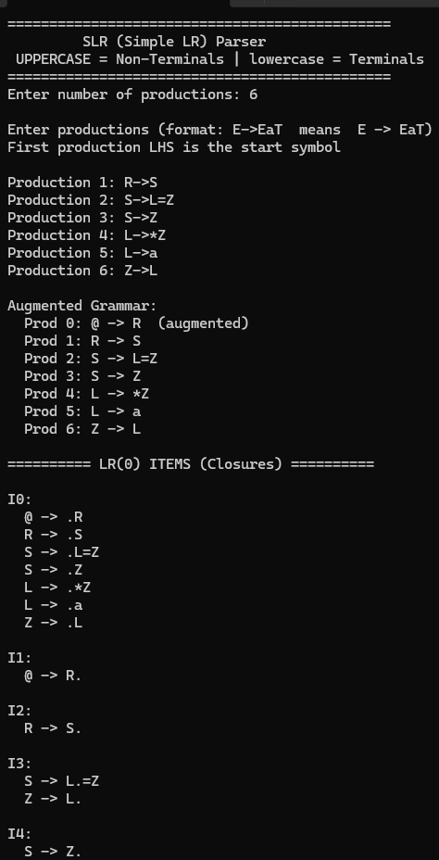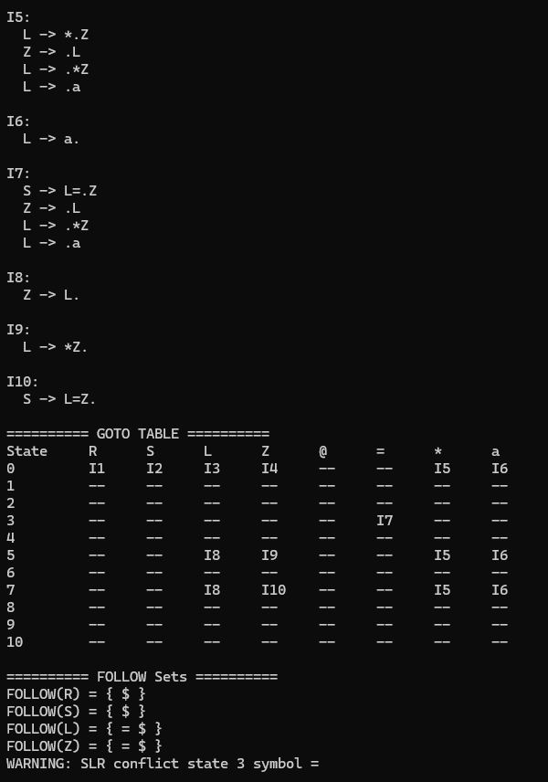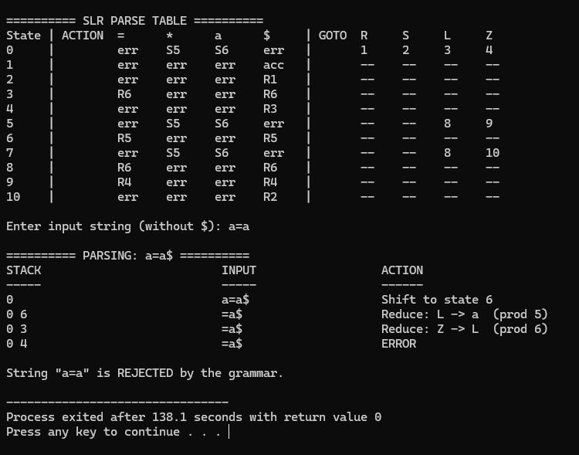

AIM
Experiment-11(a) Construct Canonical LR (CLR) parse table using C language.
Experiment-11(b) Implement the LR parsing algorithm, get both parse table and input string are inputs. Use C language for implementation.

ALGORITHM
- Input grammar productions and identify the start symbol.
- Augment the grammar by adding a new production @ → S.
- Identify all terminals and non-terminals from the grammar.
- Compute FIRST sets for all non-terminals.
- Create the initial LR(1) item set I₀ = closure([@ → .S , $]).
- Apply LR(1) closure rule: for [A → α . B β , a], add [B → .γ , b] where b ∈ FIRST(βa).
- Compute GOTO(I, X) by moving the dot over symbol X and taking closure.
- Generate the canonical collection of LR(1) states by repeating GOTO for all grammar symbols
- Construct the ACTION table:If [A → α . a β , b] and GOTO(I,a)=J, then ACTION[I,a] = shift J.
- Add REDUCE actions:If [A → α . , a] exists, then ACTION[I,a] = reduce A → α.
- Add ACCEPT action:If [ @ → S . , $ ] exists, then ACTION[I,$] = accept.
- Fill the GOTO table for transitions on non-terminals.
- Initialize stack with state 0 and append $ to the input string.
- Read current state and input symbol and consult the ACTION table.
- Perform SHIFT, REDUCE, ACCEPT, or ERROR based on the table entry.
- Repeat parsing steps until the input is accepted or rejected.

SOURCE CODE
/*
* CLR (Canonical LR) Parser
* --------------------------
* UPPERCASE letters = Non-Terminals (E, T, F, S ...)
* lowercase letters = Terminals (a, b, c, d, i ...)
*
* Input format: E=EaT means E -> EaT
* Augmented start '@' added internally: @ -> original_start
*
* LR(1) items: [A->a.b, lookahead]
* Closure: for [A->a.Bb, la], add [B->.g, x] for x in FIRST(b.la)
* Reduce: only on the specific lookahead in the item (not full FOLLOW)
*
* All variables declared at top of each function (C89 compatible)
*/

#include <stdio.h>
#include <stdlib.h>
#include <string.h>

#define MAXP 30
#define MAXS 200
#define MAXR 20
#define MAXSYM 50
#define MAXITEM 600
#define ACCEPT -2
#define ERR -3

/* Grammar */
int numProd;
char lhs[MAXP];
char rhs[MAXP][MAXR];
int rhsLen[MAXP];

/* Symbol tables */
char nonTerminals[MAXSYM]; int numNT = 0;
char terminals[MAXSYM]; int numT = 0;
char allSymbols[MAXSYM]; int numAll = 0;

/* LR(1) Item: [prod, dot, lookahead] */
typedef struct { int prod; int dot; char la; } Item1;
typedef struct { Item1 items[MAXITEM]; int count; } State1;

State1 states[MAXS];
int numStates = 0;
int gotoTbl[MAXS][MAXSYM];

/* Parse tables */
int actTable[MAXS][MAXSYM];
int gotoTable[MAXS][MAXSYM];

/* FIRST sets */
int firstSet[MAXSYM];

/* ══════════════════════════════════════════
HELPERS (uppercase=NT, lowercase=terminal)
══════════════════════════════════════════ */

int isNT(char c) { return (c >= 'A' && c <= 'Z'); }

int ntIdx(char c) {
int i;
for(i = 0; i < numNT; i++) if(nonTerminals[i] == c) return i;
return -1;
}

int tIdx(char c) {
int i;
for(i = 0; i < numT; i++) if(terminals[i] == c) return i;
return -1;
}

void addNT(char c) {
int i;
for(i = 0; i < numNT; i++) if(nonTerminals[i] == c) return;
nonTerminals[numNT++] = c;
}

void addT(char c) {
int i;
for(i = 0; i < numT; i++) if(terminals[i] == c) return;
terminals[numT++] = c;
}

void addSym(char c) {
int i;
for(i = 0; i < numAll; i++) if(allSymbols[i] == c) return;
allSymbols[numAll++] = c;
}

/* ══════════════════════════════════════════
FIRST SETS
══════════════════════════════════════════ */
void computeFirst() {
int changed, p, k, ni, old, xi, allEps;
char X;

memset(firstSet, 0, sizeof(firstSet));
changed = 1;
while(changed) {
changed = 0;
for(p = 0; p < numProd; p++) {
ni = ntIdx(lhs[p]);
old = firstSet[ni];
if(rhsLen[p] == 0) {
firstSet[ni] |= (1 << numT);
} else {
allEps = 1;
for(k = 0; k < rhsLen[p]; k++) {
X = rhs[p][k];
if(!isNT(X)) { firstSet[ni] |= (1 << tIdx(X)); allEps = 0; break; }
else {
xi = ntIdx(X);
firstSet[ni] |= (firstSet[xi] & ~(1 << numT));
if(!(firstSet[xi] & (1 << numT))) { allEps = 0; break; }
}
}
if(allEps) firstSet[ni] |= (1 << numT);
}
if(firstSet[ni] != old) changed = 1;
}
}
}

/* FIRST(rhs[p][dotPos..end] + lookahead la) as bitmask */
int firstOfBetaA(int p, int dotPos, char la) {
int res, allEps, k, xi;
char X;

res = 0;
allEps = 1;
for(k = dotPos; k < rhsLen[p]; k++) {
X = rhs[p][k];
if(!isNT(X)) { res |= (1 << tIdx(X)); allEps = 0; break; }
else {
xi = ntIdx(X);
res |= (firstSet[xi] & ~(1 << numT));
if(!(firstSet[xi] & (1 << numT))) { allEps = 0; break; }
}
}
if(allEps) {
if(la == '$') res |= (1 << numT);
else res |= (1 << tIdx(la));
}
return res;
}

/* ══════════════════════════════════════════
LR(1) CLOSURE
══════════════════════════════════════════ */
void computeClosure1(State1 *st) {
int changed, i, q, t, fmask, found, p, d;
char B, b;

changed = 1;
while(changed) {
changed = 0;
for(i = 0; i < st->count; i++) {
p = st->items[i].prod;
d = st->items[i].dot;
if(d >= rhsLen[p]) continue;
B = rhs[p][d];
if(!isNT(B)) continue;
fmask = firstOfBetaA(p, d + 1, st->items[i].la);
for(q = 0; q < numProd; q++) {
if(lhs[q] != B) continue;
for(t = 0; t <= numT; t++) {
if(!(fmask & (1 << t))) continue;
b = (t < numT) ? terminals[t] : '$';
found = 0;
for(p = 0; p < st->count; p++)
if(st->items[p].prod == q && st->items[p].dot == 0 && st->items[p].la == b)
{ found = 1; break; }
p = st->items[i].prod;
if(!found) {
st->items[st->count].prod = q;
st->items[st->count].dot = 0;
st->items[st->count].la = b;
st->count++;
changed = 1;
}
}
}
}
}
}

/* ══════════════════════════════════════════
LR(1) GOTO
══════════════════════════════════════════ */
int computeGoto1(int si, char X, State1 *out) {
int i, k, found;
Item1 ni;
State1 *st;

st = &states[si];
out->count = 0;
for(i = 0; i < st->count; i++) {
if(st->items[i].dot < rhsLen[st->items[i].prod] &&
rhs[st->items[i].prod][st->items[i].dot] == X) {
ni.prod = st->items[i].prod;
ni.dot = st->items[i].dot + 1;
ni.la = st->items[i].la;
found = 0;
for(k = 0; k < out->count; k++)
if(out->items[k].prod == ni.prod && out->items[k].dot == ni.dot && out->items[k].la == ni.la)
{ found = 1; break; }
if(!found) out->items[out->count++] = ni;
}
}
if(out->count == 0) return -1;
computeClosure1(out);
return 0;
}

int statesEqual(State1 *a, State1 *b) {
int i, j, found;
if(a->count != b->count) return 0;
for(i = 0; i < a->count; i++) {
found = 0;
for(j = 0; j < b->count; j++)
if(a->items[i].prod == b->items[j].prod &&
a->items[i].dot == b->items[j].dot &&
a->items[i].la == b->items[j].la) { found = 1; break; }
if(!found) return 0;
}
return 1;
}

/* ══════════════════════════════════════════
BUILD ALL LR(1) STATES
══════════════════════════════════════════ */
void buildStates() {
int i, j, s, found;
State1 tmp;

states[0].count = 0;
states[0].items[0].prod = 0;
states[0].items[0].dot = 0;
states[0].items[0].la = '$';
states[0].count = 1;
computeClosure1(&states[0]);
numStates = 1;

for(i = 0; i < MAXS; i++)
for(j = 0; j < MAXSYM; j++)
gotoTbl[i][j] = -1;

for(i = 0; i < numStates; i++) {
for(s = 0; s < numAll; s++) {
tmp.count = 0;
if(computeGoto1(i, allSymbols[s], &tmp) < 0) continue;
found = -1;
for(j = 0; j < numStates; j++)
if(statesEqual(&states[j], &tmp)) { found = j; break; }
if(found < 0) { states[numStates] = tmp; found = numStates++; }
gotoTbl[i][s] = found;
}
}
}

/* ══════════════════════════════════════════
PRINT STATES
══════════════════════════════════════════ */
void printStates() {
int i, j, k, s;
Item1 it;

printf("\n========== LR(1) ITEMS (Closures) ==========\n");
for(i = 0; i < numStates; i++) {
printf("\nI%d:\n", i);
for(j = 0; j < states[i].count; j++) {
it = states[i].items[j];
printf(" [%c -> ", lhs[it.prod]);
for(k = 0; k < rhsLen[it.prod]; k++) {
if(k == it.dot) printf(".");
printf("%c", rhs[it.prod][k]);
}
if(it.dot == rhsLen[it.prod]) printf(".");
printf(", %c]\n", it.la);
}
}

printf("\n========== GOTO TABLE ==========\n");
printf("%-8s", "State");
for(s = 0; s < numAll; s++) printf(" %-5c", allSymbols[s]);
printf("\n");
for(i = 0; i < numStates; i++) {
printf("%-8d", i);
for(s = 0; s < numAll; s++) {
if(gotoTbl[i][s] >= 0) printf(" I%-4d", gotoTbl[i][s]);
else printf(" %-5s", "--");
}
printf("\n");
}
}

/* ══════════════════════════════════════════
BUILD CLR PARSE TABLE
══════════════════════════════════════════ */
void buildParseTable() {
int i, j, s, p, ti, val;
Item1 it;
char X;

for(i = 0; i < MAXS; i++)
for(j = 0; j < MAXSYM; j++) { actTable[i][j] = ERR; gotoTable[i][j] = -1; }

for(i = 0; i < numStates; i++) {
for(s = 0; s < numAll; s++) {
if(gotoTbl[i][s] < 0) continue;
X = allSymbols[s];
if(isNT(X)) gotoTable[i][ntIdx(X)] = gotoTbl[i][s];
else actTable[i][tIdx(X)] = gotoTbl[i][s];
}
for(j = 0; j < states[i].count; j++) {
it = states[i].items[j];
if(it.dot < rhsLen[it.prod]) continue;
p = it.prod;
if(p == 0) { actTable[i][numT] = ACCEPT; continue; }
ti = (it.la == '$') ? numT : tIdx(it.la);
val = -(p + 10);
if(actTable[i][ti] != ERR && actTable[i][ti] != val)
printf("WARNING: CLR conflict state %d symbol %c\n", i, it.la);
actTable[i][ti] = val;
}
}
}

/* ══════════════════════════════════════════
PRINT CLR PARSE TABLE
══════════════════════════════════════════ */
void printParseTable() {
int i, t, n, v;
char c;

printf("\n========== CLR PARSE TABLE ==========\n");
printf("%-6s| ACTION", "State");
for(t = 0; t <= numT; t++) {
c = (t < numT) ? terminals[t] : '$';
printf(" %-5c", c);
}
printf(" | GOTO");
for(n = 0; n < numNT; n++) {
if(nonTerminals[n] == '@') continue;
printf(" %-4c", nonTerminals[n]);
}
printf("\n");

for(i = 0; i < numStates; i++) {
printf("%-6d| ", i);
for(t = 0; t <= numT; t++) {
v = actTable[i][t];
if(v == ERR) printf(" %-5s", "err");
else if(v == ACCEPT) printf(" %-5s", "acc");
else if(v >= 0) printf(" S%-4d", v);
else printf(" R%-4d", -(v + 10));
}
printf(" | ");
for(n = 0; n < numNT; n++) {
if(nonTerminals[n] == '@') continue;
if(gotoTable[i][n] >= 0) printf(" %-4d", gotoTable[i][n]);
else printf(" %-4s", "--");
}
printf("\n");
}
}

/* ══════════════════════════════════════════
LR PARSER
══════════════════════════════════════════ */
void parse(char *input) {
int len, ip, top, s, ai, v, p, t2, ni, g, i, pos;
char a;
int stk[500];
char stkStr[300], inStr[200];

len = (int)strlen(input);
printf("\n========== PARSING: %s$ ==========\n", input);
printf("%-30s %-22s %-25s\n", "STACK", "INPUT", "ACTION");
printf("%-30s %-22s %-25s\n", "-----", "-----", "------");

stk[0] = 0; top = 0; ip = 0;

while(1) {
s = stk[top];
a = (ip < len) ? input[ip] : '$';
ai = (a == '$') ? numT : tIdx(a);

pos = 0;
for(i = 0; i <= top; i++) pos += sprintf(stkStr + pos, "%d ", stk[i]);
for(i = ip; i < len; i++) inStr[i - ip] = input[i];
inStr[len - ip] = '\0'; strcat(inStr, "$");

if(ai < 0) { printf("%-30s %-22s Error: unknown '%c'\n", stkStr, inStr, a); return; }

v = actTable[s][ai];

if(v == ACCEPT) {
printf("%-30s %-22s ACCEPT\n", stkStr, inStr);
printf("\nString \"%s\" is ACCEPTED.\n", input); return;
} else if(v == ERR) {
printf("%-30s %-22s ERROR\n", stkStr, inStr);
printf("\nString \"%s\" is REJECTED.\n", input); return;
} else if(v >= 0) {
printf("%-30s %-22s Shift to state %d\n", stkStr, inStr, v);
stk[++top] = v; ip++;
} else {
p = -(v + 10);
printf("%-30s %-22s Reduce: %c -> ", stkStr, inStr, lhs[p]);
for(i = 0; i < rhsLen[p]; i++) printf("%c", rhs[p][i]);
printf(" (prod %d)\n", p);
top -= rhsLen[p];
t2 = stk[top]; ni = ntIdx(lhs[p]); g = gotoTable[t2][ni];
if(g < 0) { printf("GOTO error\n"); return; }
stk[++top] = g;
}
}
}

/* ══════════════════════════════════════════
MAIN
══════════════════════════════════════════ */
int main() {
int i, j, k;
char startSym;
char buf[50];
char input[200];

printf("==============================================\n");
printf(" CLR (Canonical LR) Parser\n");
printf(" UPPERCASE = Non-Terminals | lowercase = Terminals\n");
printf("==============================================\n");
printf("Enter number of productions: ");
scanf("%d", &numProd);
numProd++; getchar();

printf("\nEnter productions (format: E->EaT means E -> EaT)\n");
printf("First production LHS is the start symbol\n\n");

startSym = 0;
for(i = 1; i < numProd; i++) {
printf("Production %d: ", i);
fgets(buf, sizeof(buf), stdin);
buf[strcspn(buf, "\n")] = 0;
lhs[i] = buf[0]; k = 0;
/* buf[0]=LHS, buf[1]='-', buf[2]='>', buf[3..]=RHS */
for(j = 3; buf[j] && buf[j] != '\n'; j++) rhs[i][k++] = buf[j];
rhsLen[i] = k;
if(i == 1) startSym = lhs[1];
addNT(lhs[i]);
}

lhs[0] = '@'; rhs[0][0] = startSym; rhsLen[0] = 1;
addNT('@');

for(i = 0; i < numProd; i++)
for(j = 0; j < rhsLen[i]; j++)
if(!isNT(rhs[i][j])) addT(rhs[i][j]);

for(i = 0; i < numNT; i++) addSym(nonTerminals[i]);
for(i = 0; i < numT; i++) addSym(terminals[i]);

printf("\nAugmented Grammar:\n");
printf(" Prod 0: @ -> %c (augmented)\n", startSym);
for(i = 1; i < numProd; i++) {
printf(" Prod %d: %c -> ", i, lhs[i]);
for(j = 0; j < rhsLen[i]; j++) printf("%c", rhs[i][j]);
printf("\n");
}

computeFirst();
buildStates();
printStates();
buildParseTable();
printParseTable();

printf("\nEnter input string (without $): ");
scanf("%s", input);
parse(input);
return 0;
}

OUTPUT
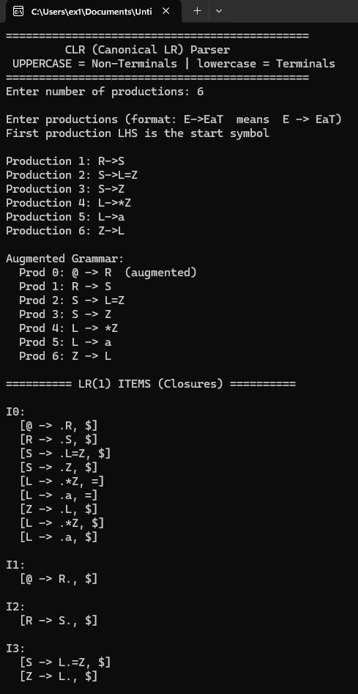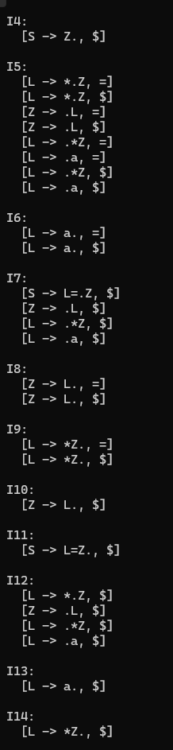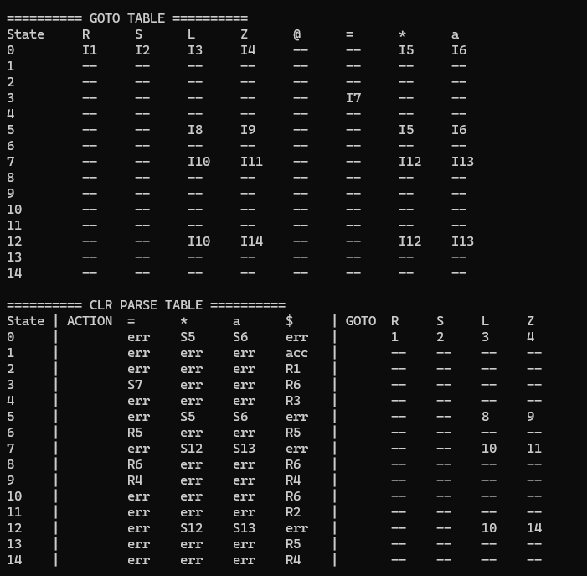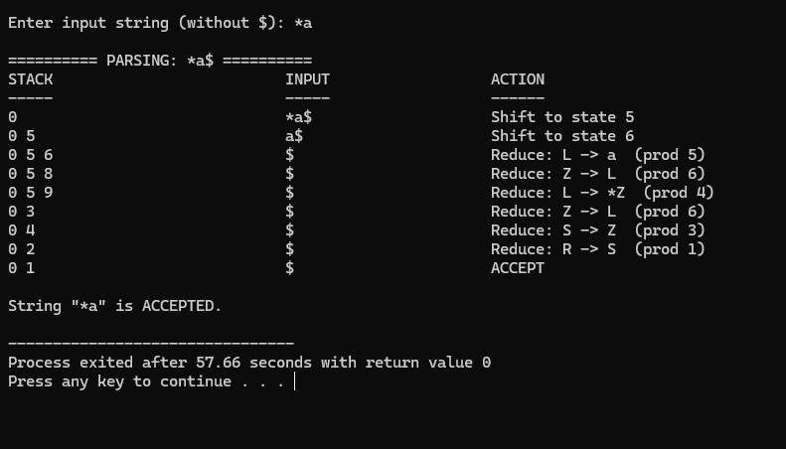

AIM
Experiment-12(a) Construct Look-Ahead LR (LALR) parse table using C language.
Experiment-12(b) Implement the LR parsing algorithm, get both parse table and input string are inputs. Use C language for implementation.

ALGORITHM

Step 1: Build full CLR LR(1) canonical collection
Step 2: Find CLR states with same CORE (same prod+dot, different lookaheads)
Step 3: Merge those states -> union lookaheads into one LALR state
Step 4: Rebuild GOTO on merged LALR states
Step 5: Build parse table using merged lookaheads for reduces

SOURCE CODE
/*
* LALR (Look-Ahead LR) Parser
* ----------------------------
* UPPERCASE letters = Non-Terminals (E, T, F, S ...)
* lowercase letters = Terminals (a, b, c, d, i ...)
*
* Algorithm:
* Step 1: Build full CLR LR(1) canonical collection
* Step 2: Find CLR states with same CORE (same prod+dot, different lookaheads)
* Step 3: Merge those states -> union lookaheads into one LALR state
* Step 4: Rebuild GOTO on merged LALR states
* Step 5: Build parse table using merged lookaheads for reduces
*
* All variables declared at top of each function (C89 compatible)
*/

#include <stdio.h>
#include <stdlib.h>
#include <string.h>

#define MAXP 30
#define MAXCLRS 300
#define MAXLALS 150
#define MAXR 20
#define MAXSYM 50
#define MAXITEM 600
#define ACCEPT -2
#define ERR -3

/* Grammar */
int numProd;
char lhs[MAXP];
char rhs[MAXP][MAXR];
int rhsLen[MAXP];

/* Symbol tables */
char nonTerminals[MAXSYM]; int numNT = 0;
char terminals[MAXSYM]; int numT = 0;
char allSymbols[MAXSYM]; int numAll = 0;

/* LR(1) Item */
typedef struct { int prod; int dot; char la; } Item1;
typedef struct { Item1 items[MAXITEM]; int count; } State1;

/* CLR states */
State1 clrStates[MAXCLRS];
int numCLR = 0;
int clrGoto[MAXCLRS][MAXSYM];

/* LALR merged states */
int lalrGroup[MAXCLRS];
State1 lalrStates[MAXLALS];
int numLALR = 0;
int lalrGoto[MAXLALS][MAXSYM];

/* Parse tables */
int actTable[MAXLALS][MAXSYM];
int gotoTable[MAXLALS][MAXSYM];

/* FIRST sets */
int firstSet[MAXSYM];

/* ══════════════════════════════════════════
HELPERS
══════════════════════════════════════════ */

int isNT(char c) { return (c >= 'A' && c <= 'Z'); }

int ntIdx(char c) {
int i;
for(i = 0; i < numNT; i++) if(nonTerminals[i] == c) return i;
return -1;
}

int tIdx(char c) {
int i;
for(i = 0; i < numT; i++) if(terminals[i] == c) return i;
return -1;
}

void addNT(char c) {
int i;
for(i = 0; i < numNT; i++) if(nonTerminals[i] == c) return;
nonTerminals[numNT++] = c;
}

void addT(char c) {
int i;
for(i = 0; i < numT; i++) if(terminals[i] == c) return;
terminals[numT++] = c;
}

void addSym(char c) {
int i;
for(i = 0; i < numAll; i++) if(allSymbols[i] == c) return;
allSymbols[numAll++] = c;
}

/* ══════════════════════════════════════════
FIRST SETS
══════════════════════════════════════════ */
void computeFirst() {
int changed, p, k, ni, old, xi, allEps;
char X;

memset(firstSet, 0, sizeof(firstSet));
changed = 1;
while(changed) {
changed = 0;
for(p = 0; p < numProd; p++) {
ni = ntIdx(lhs[p]);
old = firstSet[ni];
if(rhsLen[p] == 0) {
firstSet[ni] |= (1 << numT);
} else {
allEps = 1;
for(k = 0; k < rhsLen[p]; k++) {
X = rhs[p][k];
if(!isNT(X)) { firstSet[ni] |= (1 << tIdx(X)); allEps = 0; break; }
else {
xi = ntIdx(X);
firstSet[ni] |= (firstSet[xi] & ~(1 << numT));
if(!(firstSet[xi] & (1 << numT))) { allEps = 0; break; }
}
}
if(allEps) firstSet[ni] |= (1 << numT);
}
if(firstSet[ni] != old) changed = 1;
}
}
}

int firstOfBetaA(int p, int dotPos, char la) {
int res, allEps, k, xi;
char X;

res = 0;
allEps = 1;
for(k = dotPos; k < rhsLen[p]; k++) {
X = rhs[p][k];
if(!isNT(X)) { res |= (1 << tIdx(X)); allEps = 0; break; }
else {
xi = ntIdx(X);
res |= (firstSet[xi] & ~(1 << numT));
if(!(firstSet[xi] & (1 << numT))) { allEps = 0; break; }
}
}
if(allEps) {
if(la == '$') res |= (1 << numT);
else res |= (1 << tIdx(la));
}
return res;
}

/* ══════════════════════════════════════════
LR(1) CLOSURE
══════════════════════════════════════════ */
void computeClosure1(State1 *st) {
int changed, i, q, t, fmask, found, p, d;
char B, b;

changed = 1;
while(changed) {
changed = 0;
for(i = 0; i < st->count; i++) {
p = st->items[i].prod;
d = st->items[i].dot;
if(d >= rhsLen[p]) continue;
B = rhs[p][d];
if(!isNT(B)) continue;
fmask = firstOfBetaA(p, d + 1, st->items[i].la);
for(q = 0; q < numProd; q++) {
if(lhs[q] != B) continue;
for(t = 0; t <= numT; t++) {
if(!(fmask & (1 << t))) continue;
b = (t < numT) ? terminals[t] : '$';
found = 0;
for(p = 0; p < st->count; p++)
if(st->items[p].prod == q && st->items[p].dot == 0 && st->items[p].la == b)
{ found = 1; break; }
p = st->items[i].prod;
if(!found) {
st->items[st->count].prod = q;
st->items[st->count].dot = 0;
st->items[st->count].la = b;
st->count++;
changed = 1;
}
}
}
}
}
}

/* ══════════════════════════════════════════
LR(1) GOTO
══════════════════════════════════════════ */
int computeGoto1(int si, char X, State1 *out) {
int i, k, found;
Item1 ni;
State1 *st;

st = &clrStates[si];
out->count = 0;
for(i = 0; i < st->count; i++) {
if(st->items[i].dot < rhsLen[st->items[i].prod] &&
rhs[st->items[i].prod][st->items[i].dot] == X) {
ni.prod = st->items[i].prod;
ni.dot = st->items[i].dot + 1;
ni.la = st->items[i].la;
found = 0;
for(k = 0; k < out->count; k++)
if(out->items[k].prod == ni.prod && out->items[k].dot == ni.dot && out->items[k].la == ni.la)
{ found = 1; break; }
if(!found) out->items[out->count++] = ni;
}
}
if(out->count == 0) return -1;
computeClosure1(out);
return 0;
}

int clrEqual(State1 *a, State1 *b) {
int i, j, found;
if(a->count != b->count) return 0;
for(i = 0; i < a->count; i++) {
found = 0;
for(j = 0; j < b->count; j++)
if(a->items[i].prod == b->items[j].prod &&
a->items[i].dot == b->items[j].dot &&
a->items[i].la == b->items[j].la) { found = 1; break; }
if(!found) return 0;
}
return 1;
}

/* ══════════════════════════════════════════
BUILD CLR STATES
══════════════════════════════════════════ */
void buildCLRStates() {
int i, j, s, found;
State1 tmp;

clrStates[0].count = 0;
clrStates[0].items[0].prod = 0;
clrStates[0].items[0].dot = 0;
clrStates[0].items[0].la = '$';
clrStates[0].count = 1;
computeClosure1(&clrStates[0]);
numCLR = 1;

for(i = 0; i < MAXCLRS; i++)
for(j = 0; j < MAXSYM; j++)
clrGoto[i][j] = -1;

for(i = 0; i < numCLR; i++) {
for(s = 0; s < numAll; s++) {
tmp.count = 0;
if(computeGoto1(i, allSymbols[s], &tmp) < 0) continue;
found = -1;
for(j = 0; j < numCLR; j++)
if(clrEqual(&clrStates[j], &tmp)) { found = j; break; }
if(found < 0) { clrStates[numCLR] = tmp; found = numCLR++; }
clrGoto[i][s] = found;
}
}
}

/* ══════════════════════════════════════════
SAME CORE CHECK (same prod+dot, any lookahead)
══════════════════════════════════════════ */
int sameCore(int a, int b) {
int i, j, found;
State1 *sa, *sb;

sa = &clrStates[a];
sb = &clrStates[b];
if(sa->count != sb->count) return 0;
for(i = 0; i < sa->count; i++) {
found = 0;
for(j = 0; j < sb->count; j++)
if(sa->items[i].prod == sb->items[j].prod &&
sa->items[i].dot == sb->items[j].dot) { found = 1; break; }
if(!found) return 0;
}
return 1;
}

/* ══════════════════════════════════════════
MERGE CLR -> LALR
Group states with same core, union lookaheads
══════════════════════════════════════════ */
void mergeLALR() {
int i, j, k, m, lg, found;
Item1 it;

for(i = 0; i < numCLR; i++) lalrGroup[i] = -1;
numLALR = 0;

for(i = 0; i < numCLR; i++) {
if(lalrGroup[i] >= 0) continue;
lg = numLALR++;
lalrGroup[i] = lg;
lalrStates[lg] = clrStates[i];

for(j = i + 1; j < numCLR; j++) {
if(lalrGroup[j] >= 0) continue;
if(!sameCore(i, j)) continue;
lalrGroup[j] = lg;
/* union lookaheads from clrStates[j] into lalrStates[lg] */
for(k = 0; k < clrStates[j].count; k++) {
it = clrStates[j].items[k];
found = 0;
for(m = 0; m < lalrStates[lg].count; m++)
if(lalrStates[lg].items[m].prod == it.prod &&
lalrStates[lg].items[m].dot == it.dot &&
lalrStates[lg].items[m].la == it.la) { found = 1; break; }
if(!found) lalrStates[lg].items[lalrStates[lg].count++] = it;
}
}
}

/* rebuild GOTO on LALR states */
for(i = 0; i < MAXLALS; i++)
for(j = 0; j < MAXSYM; j++)
lalrGoto[i][j] = -1;

for(i = 0; i < numCLR; i++) {
lg = lalrGroup[i];
for(j = 0; j < numAll; j++) {
if(clrGoto[i][j] < 0) continue;
lalrGoto[lg][j] = lalrGroup[clrGoto[i][j]];
}
}
}

/* ══════════════════════════════════════════
PRINT LALR STATES
══════════════════════════════════════════ */
void printLALRStates() {
int i, j, k, s, c;

printf("\nCLR states: %d => LALR states after merge: %d\n", numCLR, numLALR);

printf("\n========== LALR ITEMS (Merged Closures) ==========\n");
for(i = 0; i < numLALR; i++) {
printf("\nI%d (merged from CLR:", i);
for(c = 0; c < numCLR; c++) if(lalrGroup[c] == i) printf(" I%d", c);
printf("):\n");
for(j = 0; j < lalrStates[i].count; j++) {
printf(" [%c -> ", lhs[lalrStates[i].items[j].prod]);
for(k = 0; k < rhsLen[lalrStates[i].items[j].prod]; k++) {
if(k == lalrStates[i].items[j].dot) printf(".");
printf("%c", rhs[lalrStates[i].items[j].prod][k]);
}
if(lalrStates[i].items[j].dot == rhsLen[lalrStates[i].items[j].prod]) printf(".");
printf(", %c]\n", lalrStates[i].items[j].la);
}
}

printf("\n========== LALR GOTO TABLE ==========\n");
printf("%-8s", "State");
for(s = 0; s < numAll; s++) printf(" %-5c", allSymbols[s]);
printf("\n");
for(i = 0; i < numLALR; i++) {
printf("%-8d", i);
for(s = 0; s < numAll; s++) {
if(lalrGoto[i][s] >= 0) printf(" I%-4d", lalrGoto[i][s]);
else printf(" %-5s", "--");
}
printf("\n");
}
}

/* ══════════════════════════════════════════
BUILD LALR PARSE TABLE
══════════════════════════════════════════ */
void buildParseTable() {
int i, j, s, p, ti, val;
Item1 it;
char X;

for(i = 0; i < MAXLALS; i++)
for(j = 0; j < MAXSYM; j++) { actTable[i][j] = ERR; gotoTable[i][j] = -1; }

for(i = 0; i < numLALR; i++) {
for(s = 0; s < numAll; s++) {
if(lalrGoto[i][s] < 0) continue;
X = allSymbols[s];
if(isNT(X)) gotoTable[i][ntIdx(X)] = lalrGoto[i][s];
else actTable[i][tIdx(X)] = lalrGoto[i][s];
}
for(j = 0; j < lalrStates[i].count; j++) {
it = lalrStates[i].items[j];
if(it.dot < rhsLen[it.prod]) continue;
p = it.prod;
if(p == 0) { actTable[i][numT] = ACCEPT; continue; }
ti = (it.la == '$') ? numT : tIdx(it.la);
val = -(p + 10);
if(actTable[i][ti] != ERR && actTable[i][ti] != val)
printf("WARNING: LALR conflict state %d symbol %c\n", i, it.la);
actTable[i][ti] = val;
}
}
}

/* ══════════════════════════════════════════
PRINT LALR PARSE TABLE
══════════════════════════════════════════ */
void printParseTable() {
int i, t, n, v;
char c;

printf("\n========== LALR PARSE TABLE ==========\n");
printf("%-6s| ACTION", "State");
for(t = 0; t <= numT; t++) {
c = (t < numT) ? terminals[t] : '$';
printf(" %-5c", c);
}
printf(" | GOTO");
for(n = 0; n < numNT; n++) {
if(nonTerminals[n] == '@') continue;
printf(" %-4c", nonTerminals[n]);
}
printf("\n");

for(i = 0; i < numLALR; i++) {
printf("%-6d| ", i);
for(t = 0; t <= numT; t++) {
v = actTable[i][t];
if(v == ERR) printf(" %-5s", "err");
else if(v == ACCEPT) printf(" %-5s", "acc");
else if(v >= 0) printf(" S%-4d", v);
else printf(" R%-4d", -(v + 10));
}
printf(" | ");
for(n = 0; n < numNT; n++) {
if(nonTerminals[n] == '@') continue;
if(gotoTable[i][n] >= 0) printf(" %-4d", gotoTable[i][n]);
else printf(" %-4s", "--");
}
printf("\n");
}
}

/* ══════════════════════════════════════════
LR PARSER
══════════════════════════════════════════ */
void parse(char *input) {
int len, ip, top, s, ai, v, p, t2, ni, g, i, pos;
char a;
int stk[500];
char stkStr[300], inStr[200];

len = (int)strlen(input);
printf("\n========== PARSING: %s$ ==========\n", input);
printf("%-30s %-22s %-25s\n", "STACK", "INPUT", "ACTION");
printf("%-30s %-22s %-25s\n", "-----", "-----", "------");

stk[0] = 0; top = 0; ip = 0;

while(1) {
s = stk[top];
a = (ip < len) ? input[ip] : '$';
ai = (a == '$') ? numT : tIdx(a);

pos = 0;
for(i = 0; i <= top; i++) pos += sprintf(stkStr + pos, "%d ", stk[i]);
for(i = ip; i < len; i++) inStr[i - ip] = input[i];
inStr[len - ip] = '\0'; strcat(inStr, "$");

if(ai < 0) { printf("%-30s %-22s Error: unknown '%c'\n", stkStr, inStr, a); return; }

v = actTable[s][ai];

if(v == ACCEPT) {
printf("%-30s %-22s ACCEPT\n", stkStr, inStr);
printf("\nString \"%s\" is ACCEPTED.\n", input); return;
} else if(v == ERR) {
printf("%-30s %-22s ERROR\n", stkStr, inStr);
printf("\nString \"%s\" is REJECTED.\n", input); return;
} else if(v >= 0) {
printf("%-30s %-22s Shift to state %d\n", stkStr, inStr, v);
stk[++top] = v; ip++;
} else {
p = -(v + 10);
printf("%-30s %-22s Reduce: %c -> ", stkStr, inStr, lhs[p]);
for(i = 0; i < rhsLen[p]; i++) printf("%c", rhs[p][i]);
printf(" (prod %d)\n", p);
top -= rhsLen[p];
t2 = stk[top]; ni = ntIdx(lhs[p]); g = gotoTable[t2][ni];
if(g < 0) { printf("GOTO error\n"); return; }
stk[++top] = g;
}
}
}

/* ══════════════════════════════════════════
MAIN
══════════════════════════════════════════ */
int main() {
int i, j, k;
char startSym;
char buf[50];
char input[200];

printf("==============================================\n");
printf(" LALR (Look-Ahead LR) Parser\n");
printf(" UPPERCASE = Non-Terminals | lowercase = Terminals\n");
printf("==============================================\n");
printf("Enter number of productions: ");
scanf("%d", &numProd);
numProd++; getchar();

printf("\nEnter productions (format: E->EaT means E -> EaT)\n");
printf("First production LHS is the start symbol\n\n");

startSym = 0;
for(i = 1; i < numProd; i++) {
printf("Production %d: ", i);
fgets(buf, sizeof(buf), stdin);
buf[strcspn(buf, "\n")] = 0;
lhs[i] = buf[0]; k = 0;
/* buf[0]=LHS, buf[1]='-', buf[2]='>', buf[3..]=RHS */
for(j = 3; buf[j] && buf[j] != '\n'; j++) rhs[i][k++] = buf[j];
rhsLen[i] = k;
if(i == 1) startSym = lhs[1];
addNT(lhs[i]);
}

lhs[0] = '@'; rhs[0][0] = startSym; rhsLen[0] = 1;
addNT('@');

for(i = 0; i < numProd; i++)
for(j = 0; j < rhsLen[i]; j++)
if(!isNT(rhs[i][j])) addT(rhs[i][j]);

for(i = 0; i < numNT; i++) addSym(nonTerminals[i]);
for(i = 0; i < numT; i++) addSym(terminals[i]);

printf("\nAugmented Grammar:\n");
printf(" Prod 0: @ -> %c (augmented)\n", startSym);
for(i = 1; i < numProd; i++) {
printf(" Prod %d: %c -> ", i, lhs[i]);
for(j = 0; j < rhsLen[i]; j++) printf("%c", rhs[i][j]);
printf("\n");
}

computeFirst();
printf("\nStep 1: Building CLR LR(1) collection...\n");
buildCLRStates();
printf(" CLR states: %d\n", numCLR);
printf("Step 2: Merging states with same core -> LALR...\n");
mergeLALR();

printLALRStates();
buildParseTable();
printParseTable();

printf("\nEnter input string (without $): ");
scanf("%s", input);
parse(input);
return 0;
}

OUTPUT

